PROJECT DEVELOPMENT PHASE SPRINT-3 TEST CASE

|  |  |
| --- | --- |
| Date | 08 November 2022 |
| Team ID | PNT2022TMID12310 |
| Project Name | IoT Based Smart Crop Protection System for Agriculture |
| Maximum Marks | 8 Marks |

Recent Event:

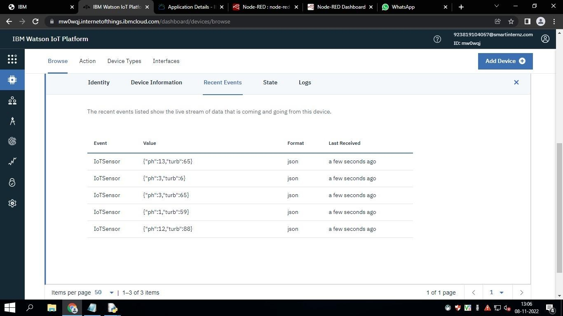

**Node-Red Output:**

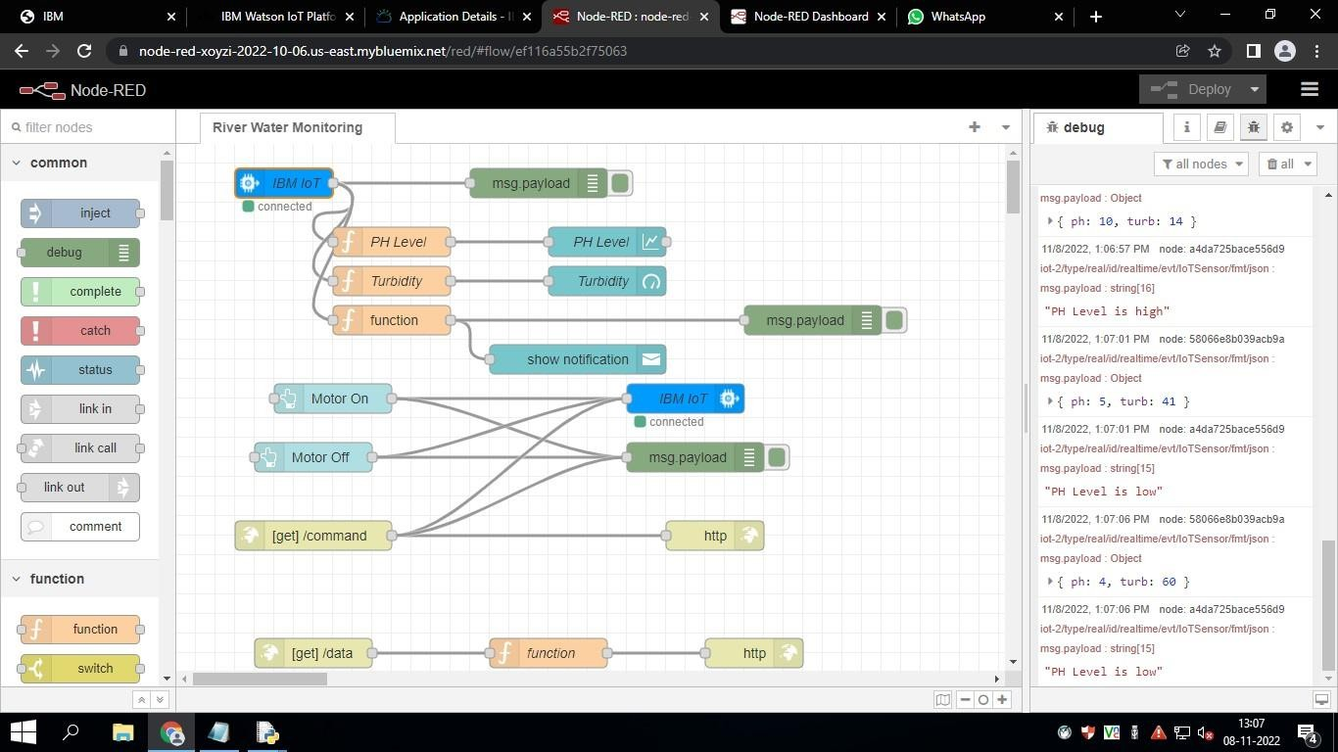

Output:

